

*Data Validation:*

*Accounting*

**Table of Contents**

Data Validation 3

Why 3

Roles & Responsibilities 3

Chart of Accounts 4

Why 4

What to check 5

How 5

Roles & Responsibilities 5

General Ledger 6

Why 6

What to check 6

How 8

Roles & Responsibilities 8

Data Validation – Full Circle 9

Data Imported 9

Data Validated 9

Data Processed 9

Postings 9

Reports 9

Why Data Validation Is Critical 10

Lower Risks 10

Go Live Duration 10

Customer Service 10

Procurement 10

Reporting 10

Success 10

# Data Validation

## Why

Why is data validation critical to any ERP implementation? Data is one of the most important parts of any implementation. The old saying of “Garbage In / Garbage Out” can be applied here. If we load bad or poor-quality data, the outputs of that data will be bad or have poor-quality. The more data validation that is done during implementation, the better the overall outputs will be. Taking ownership of the data begins with data validation. It will also provide a smoother transition and reduce or eliminate issues at Go Live. Data and data validation are key to a successful Go Live.

## Roles & Responsibilities

There are several roles that are involved with data validation. It’s a team effort. The Data Specialists, the Product Specialists, Subject Matter Experts (SMEs) and End Users have critical roles to play in data validation.

The Data Specialist’s role in validation is the same for every section so we will discuss here. It begins with the load file. Along with the Product Specialist (PS), they will review the file and determine where the data will reside in DEACOM. The Data Specialist’s responsibility is to confirm record counts and validate the information in the file loaded to the fields mapped in the data profile. This is the first level of data validation. The data profile will be modified to fix any issues found during this validation. However, the file may be missing key information that the data specialist does not know exists or during implementation new data is identified that is required to support a new process.

Data Specialists can also provide spreadsheets that can be used to easily filter or sort and review many records at one time. **Note: these spreadsheets are for validation only and will not be used to update every field on the spreadsheet. However, the spreadsheets can be used to update a single field.** The root cause of any data issue will be researched, and the data profiles updated so the data can be updated, and new records will come in with the proper changes and existing records will be updated.

The Product Specialist’s role in validation is to review the data loaded for every section and help discover, during Standard Operating Procedures (SOPs) validation, if we are missing any key data, while at the same time validating these processes using the imported data. This data will also be used in Mock Go Live and Conference Room Pilots (CRPs).

# Chart of Accounts

## Why

The Chart of Accounts are the general ledger accounts used by a company to determine how much money was spent and received. These accounts allow companies to accurately and correctly report on expenses and profits in the general ledger. Almost every area of the system touches the general ledger. Vendors have the accounts payable (AP) account on them. Customers have accounts receivable (AR) accounts on them. Items have numerous accounts like inventory, adjustment, production, expense and revenue accounts. When most transactions are performed, there can be several general ledger postings that happen. If the accounts are not correct, the system will not be able to provide accurate reports and could misstate revenue and/or expenses.

It is critical if changing the Chart of Accounts that the mapping file contains the proper mapping. During the validation of the general ledger, trial balance, profit and loss and balance sheet reports are compared to legacy reports to ensure the accounts contain the correct data. If a mapping error is found, it is fixed in the mapping file, and the data is reimported. Having accurate historical data for year over year comparison is vital to the accounting team and others for historical analysis.

There are several places in DEACOM where you can setup General Ledger (GL) overrides. The primary location is at the Facility level. These overrides allow the DEACOM system to change the general ledger account used by applying specific overrides configured on the GL Overrides tab on the Facility record, driven by the facility field on transactions. Some or all Facilities can use the same or different general ledger accounts. For example, there is a base inventory account of 11000-00-000 but Facility A’s inventory account is 11000-01-000 and Facility B’s account is 11000-02-000. If the GL Overrides are not validated, inventory will be showing in the wrong general ledger account, which will overstate or understate each facilities’ inventory.

## What to check

* In DEACOM, go to **Accounting > Maintenance > Chart of Accounts**

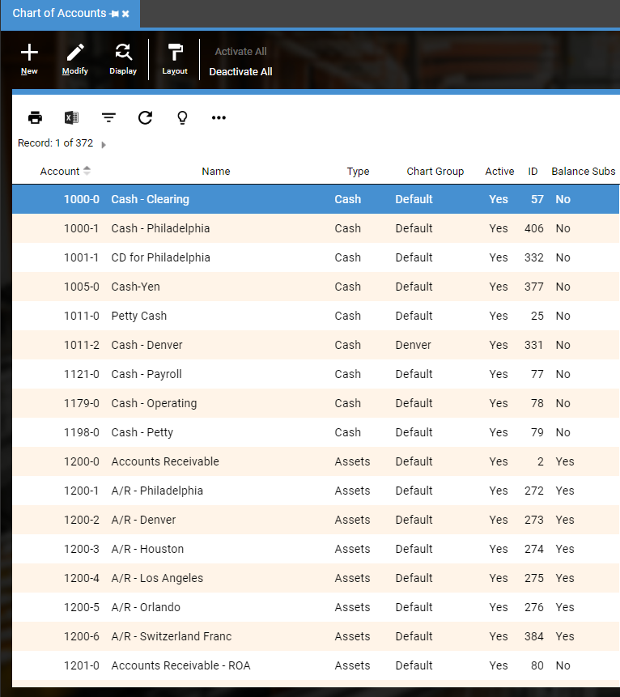

* Compare to Chart of Accounts from legacy system (or new Chart of Accounts, if applicable)

Validate Account Number, Name, Type and Chart Group

Validate Currency (only filled in if using a different currency than default)

## How

The best way is to bring the Chart of Accounts up in the legacy system and bring the Chart of Accounts up in DEACOM. Carefully compare the data for each field. If you find information is missing or in the wrong field, contact the data specialist and they will determine why this is happening.

## Roles & Responsibilities

Typically, Accounting has the responsibility to validate the data. They use the data every day and can easily spot if key data is missing.

# General Ledger

## Why

Journal entries, which make up the General Ledger, provide an audit trail and a means of analyzing the effects of the transactions on an organization's financial position. DEACOM creates most entries automatically through system transactions such as purchasing, sales, and production. Historical journal entries are loaded so the general ledger has the current financial position. It is critical that the General Ledger be validated to ensure the accounts have the correct dollar amounts. If the GL is not accurate, financial reports would be inaccurate.

## What to check

The best place to start is with the beginning balances. Today’s balance is calculated from the beginning balance and all the activity from then until today. Check the account numbers and the dollars amounts. If multiple facilities have independent general ledgers, check by running report by the facility segment. Then run these reports year by year.

**Check beginning balances:**

* In DEACOM, go to **Accounting > Accounting Reporting** >
* **Report Type** = Trial Balance
* **Start Date** = First Day of First Fiscal Year loaded
* **End date** = First Day of First Fiscal Year loaded
* **Show Items** = All accounts
* Add custom criteria to right section
* Click on **View**

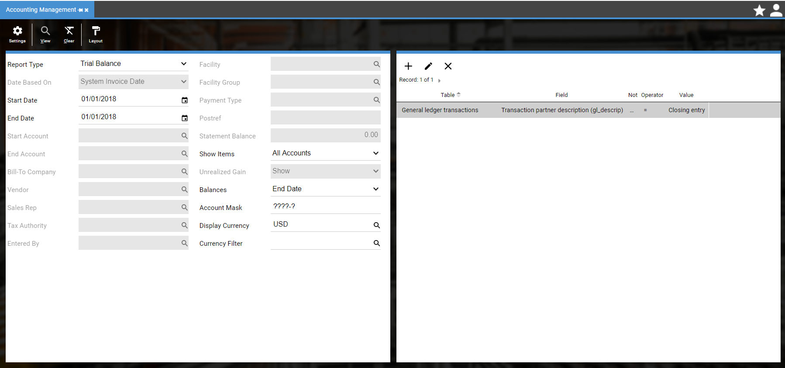

* Check that the account numbers and dollar amounts are correct.

**Check each fiscal year:**

* In DEACOM, go to **Accounting > Accounting Reporting** >
* **Report Type** = Trial Balance
* **Start Date** = First Day of First Fiscal Year Loaded
* **End date** = Last Day of First Fiscal Year Loaded
* **Show Items** = All accounts
* Click on **View**

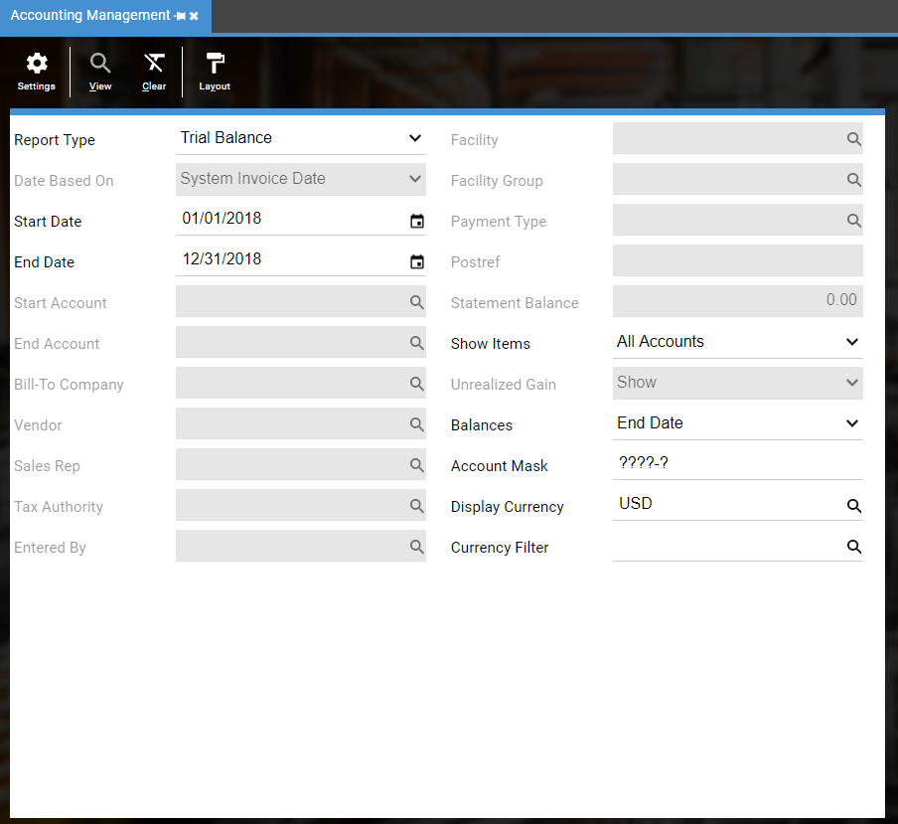

* Compare to Trial Balance reports from your Legacy system run for the same timeframe. (Do not compare to the data load file.) Run each fiscal year separately.

Confirm total debits and credits in each account match

## How

The best way is to bring the Trial Balance report up in the legacy system and bring the Trial Balance report up in DEACOM. Confirm total debits and credits in each account match. Carefully compare the each year’s activity builds the total for today. If accounts have the wrong amounts, it can be due to a bad load file or incorrect mapping table. Confirm the GL is in balance.

## Roles & Responsibilities

Typically, Subject Matter Experts and Accounting have the responsibility to validate the general Ledger data. If department specific financial reports are generated, those departments should validate those reports.

# Data Validation – Full Circle

Below is the full circle for validation.

## Data Imported

Data is imported and validated by the Data Specialists and/or Product Specialist. This validation is a comparison to the load files provided and to confirm the data is going into the correct fields.

## Data Validated

Once imported, it is important for data to be validated by the Subject Matter Experts and/or End Users. This validation is a comparison to the legacy system. Data specialists do not know what is missing if the file never contained the information.

## Data Processed

Once the data is validated, it is time to use the imported data by doing transactions in DEACOM. This ensures the imported data will transact properly with customer specific data. This builds the End Users’ confidence and confidence in DEACOM is higher.

## Postings

Once the data is used in transactions, it is imperative that the general ledger postings are reviewed. That will ensure the configuration of the items, customers, and facilities are posting the dollars to the correct accounts.

## Reports

Once all of the above is completed, run the reports needed to run your business. Are the proper results being captured? All necessary reports should be created and validated before Go Live.

# Why Data Validation Is Critical

When the data has been validated…

## Lower Risks

It has been proven to reduce the risks at Go Live. Less unforeseen issues arise if the data processes have been validated. Practicing with the validated data ensures daily transactions will be able to be completed and lowers overall risks.

## Go Live Duration

It has been proven to reduce the amount of time required for the actual Go Live. If historical data is imported and validated before Go Live, it reduces what needs to be validated during the Go Live. If doing several phases, it will reduce the amount of time Production systems need to be down.

## Customer Service

It will ensure customers will receive accurate orders and invoices. Customer payments can be applied to the correct orders.

## Procurement

It will ensure vendors continue to receive accurate orders and send the material needed for Production. Payments will be sent to the correct Remit to.

## Reporting

Accurate reporting is the result of validation, whether validating imported data or validating manually entered orders. Data that is accurate and usable is crucial to every company to make informed decisions.

## Success

Validated data is the first step to a successful Go Live. The more accurate the data, the quicker the road to success.